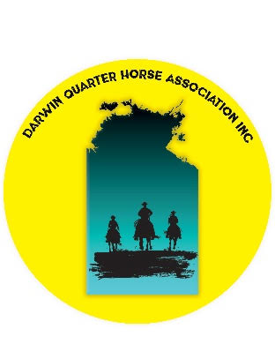
DARWIN
QUARTER HORSE
ASSOCIATION INC
P.O. Box 1881
Coolalinga NT 0839
Email: dqhainc@gmail.com

Talent Release Authorisation Form
I give permission for the Darwin Quarter Horse Club (DQHA) to use my name and photographs, video or audio recordings of myself/my child for marketing and promotional purposes including but not limited to printed publications, newsletters, posters, advertisements, websites, social media, television commercials, billboards, and cinema and radio advertisements.
The permission will continue until I revoke permission in writing to the Darwin Quarter Horse Club. In the situation where permission is revoked, every effort will be made to remove the image from future distribution; however this may not be possible or practical in some situations.
I have read and understand the above: Yes / No
Name:
Guardian name:
if under 18 years:
Email: |  |  | Phone:
Do you identify as being of Aboriginal or Torres Strait Islander descent? (Wherever possible, the Darwin Quarter Horse Club will remain sensitive to cultural, family and personal sensitivities.  This information is optional and will not be used for any purpose involving discrimination.) |  |  |  |  | Yes / No
Signature: |  |  |  |  | Date (dd/mm/yyyy):
Notes or special
considerations

Office use | Collected on behalf of the Darwin Quarter Horse Club
Name:
Organisation:
Email: |  | Phone:
Description of job
and person:
(i.e. region, location, event name, clothing, hair colour, gender, position in shot)
Notes:
(sensitivities, exclusions, copyright considerations, original image number, file name)

Talent Information Sheet
The Darwin Quarter Horse Club (DQHA) is collecting your information to obtain permission to use photos, video or audio recordings of you in DQHA advertising, documents, promotional materials, websites and social media accounts. Photos, video (now referred to as images), audio recordings or other personal information described in this form may be supplied to DQHA members, contractors or service providers (for example, graphic designers) engaged by DQHA to produce these materials but will not be provided to any other person or organisation for purposes other than described.
Before you agree to any images or audio recordings of you being used by DQHA, there are some important things you need to know.

What will happen to my images once they are taken?
DQHA will store your images digitally in its photographic library database. The talent release form that you signed will be filed with your images. Once stored in the database, your images may be used by DQHA for a wide variety of purposes, ongoing, until advised otherwise by you in writing.

Who can use my images?
Your images cannot be shared with any person, organisation or company outside of DQHA, other than those specified, without your express permission. This includes private companies, political parties, and charitable organisations. Images may be shared with a Minister’s office in relation to a project, initiative or awareness messaging.

Where will my images or audio be used?
Your images may be used in a variety of applications. Some of the typical places could include printed brochures and flyers, newspaper advertising, magazines and journals, television commercials, radio commercials, DQHA events and displays, newsletters, websites and social media channels, outdoor billboards and banners and others as required.

What if I don’t want my photograph to be used somewhere?
It can be quite a surprise to see your photograph blown up two metres tall at a display, or to suddenly find yourself appearing on television. You need to be aware that your photograph may be used in these situations unless you ask for it not to be. If there are circumstances where you do not want your photo used, make sure you write that down on the talent release authorisation you sign.

How do I request my photos be removed from the database?
You should send an email to DQHA to let us know.

Why do you need to know if I identify as being of Aboriginal or Torres Strait Islander decent?
DQHA may deliver a wide range of services and information specifically designed to reach Territorians, some of who identify as being of Aboriginal or Torres Strait Islander descent and we appreciate that there may be certain cultural sensitivities about using your image.
You are entitled to access and amend the information provided by you.
For more information or to update your records please contact:
Darwin Quarter Horse Association
E: dqhinc@gmail.com

